Software Requirements Specification (SRS)
Project Name: LexVellum Differential
Course: Software Engineering
Submission Date: Feb 14, 2026
Project Team:
- Team Lead: Moeeed (23L-0686, Section A)
- Member 1: Kharia Imran (23L-0512, Section B)
- Member 2: Malaika Khan (22L-7770, Section B)

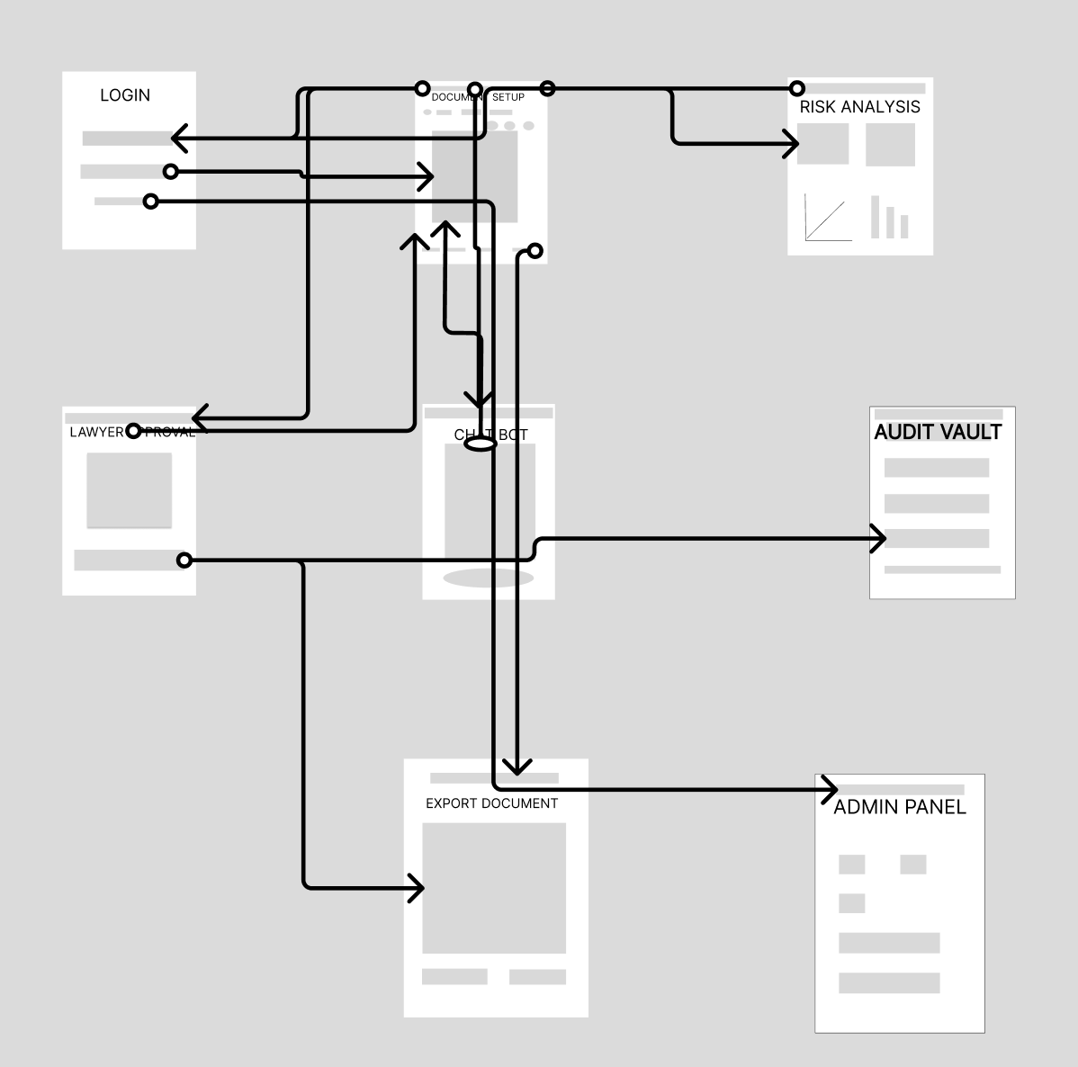

1. Introduction
1.1 Purpose This document describes the functional and non-functional requirements of the LexVellum Differential system. It serves as a reference for developers, stakeholders, and project managers to understand the scope, features, and technical constraints of the platform.
1.2 Scope LexVellum Differential is a sophisticated, AI-driven compliance engine designed to solve the "Compliance Paradox" faced by international e-commerce leaders. Our client, Palwasha Gillani, CEO of QuantCart, operates a high-growth global storefront that requires a single, unified "Terms of Service" (ToS) document to satisfy a fragmented legal landscape. The system automates the legal review of ToS documents by simultaneously reconciling the strict privacy mandates of the GDPR (EU), the transparency requirements of the CCPA (California), and the local regulations of UAE Federal Law.
By utilizing a Retrieval-Augmented Generation (RAG) architecture, LexVellum performs a parallel "Differential Analysis" across these jurisdictions. The system solves QuantCart's primary pain points by providing Multi-Dimensional Risk Analytics and Automated Redlining. Central to this solution is the Immutable Audit Trail—a permanent "Truth Log" that records every legal modification. This ensures that every change made to satisfy a law is documented, providing Palwasha with a historical defense during government audits.
1.3 Definitions
- ToS: Terms of Service.
- RAG: Retrieval-Augmented Generation (the AI architecture used to search legal texts).
- Audit Vault: An immutable, permanent "Truth Log" tracking every document edit.
- Differential Analysis: A parallel scan comparing a single document against multiple distinct legal databases simultaneously.

2. Overall Description
2.1 Product Perspective The system is a Single-Tenant, web-based SaaS application connected to a centralized relational database (for user management and the Audit Vault) and a RAG-enabled Vector Database (for storing and querying regional laws). It provides information, not legal advice, and the final web publishing remains strictly under human control.

3. Use Cases & Functional Requirements
This section defines 45 specific Use Cases detailing how users interact with LexVellum, and the corresponding Functional Requirements (FR) needed to build them.

3.1 Authentication & Account Management
Use Case 1: CEO logs into the system.
- FR1: The system shall allow the CEO to navigate to the login screen and enter her specific master email and password.
Use Case 2: CEO requests a password reset.
- FR2: The system shall allow the CEO to request a secure password reset link sent to her master email.
Use Case 3: CEO adds a new Editor to the system.
- FR3: The system shall allow the CEO to create a new user account by inputting an employee's email, assigning them an "Editor" role, and creating a temporary password.
Use Case 4: CEO adds a new Approver to the system.
- FR4: The system shall allow the CEO to create a new user account by inputting a lawyer's email, assigning them an "Approver" role, and creating a temporary password.
Use Case 5: CEO delivers credentials offline.
- FR5: The system relies on the CEO manually providing the temporary password to the employee/lawyer outside of the system (No automated credential emails sent).
Use Case 6: Employee logs into the system.
- FR6: The system shall allow the team member or lawyer to log in by entering their email and the specific password assigned to them by the CEO.
Use Case 7: System enforces role-based access.
- FR7: Upon successful login, the system shall strictly restrict the user's access to screens and features based on the role assigned by the CEO.
Use Case 8: CEO revokes user access.
- FR8: The system shall allow the CEO to delete a user's account, instantly invalidating their email and password from the database.
Use Case 9: User logs out of the system.
- FR9: The system shall provide a secure logout button allowing any active user to terminate their current session and return to the main login screen.

3.2 Document Setup & RAG Initialization
Use Case 10: User uploads a new document.
- FR10: The system shall allow the user to upload a draft Terms of Service (ToS) file.
Use Case 11: User deletes a document draft.
- FR11: The system shall allow the user to delete a draft from their workspace.
Use Case 12: User views document list.
- FR12: The system shall display a list of all currently active ToS drafts in the user's workspace.
Use Case 13: User selects target jurisdictions.
- FR13: The system shall allow the user to select specific jurisdictions to scan against (EU, USA, UAE) via checkboxes.
Use Case 14: User views single jurisdiction impact.
- FR14: The system shall allow the user to view how the ToS performs in different countries as an individual selection.
Use Case 15: User initiates full Differential Analysis.
- FR15: The system shall allow the user to click a button to start the Differential Analysis, which will scan the selected databases combined.
Use Case 16: System processes RAG query.
- FR16: The system shall securely query the RAG-enabled Vector Database in the background to analyze the document text against selected laws.

3.3 Visual Risk Analytics (The Dashboard)
Use Case 17: User reviews Compliance Heatmap.
- FR17: The system shall display a Compliance Heatmap allowing the user to visually identify category weaknesses.
Use Case 18: User reviews Violation Bar Charts.
- FR18: The system shall display Stacked Violation Bar Charts to show conflict volume and severity per country.
Use Case 19: User identifies critical severity issues.
- FR19: The system shall use Red/Yellow color-coding on the charts to help the user immediately identify critical issues versus warnings.
Use Case 20: User views Audit Trend Line.
- FR20: The system shall display an Audit Trend Line tracking the document’s journey toward 100% compliance over time.
Use Case 21: Dashboard updates dynamically.
- FR21: The system shall automatically update the graphs instantly when a document fix is made.
Use Case 22: User filters analytics by region.
- FR22: The system shall allow users to click a region on the dashboard to filter the displayed violations to only that specific area.

3.4 AI Editor & Redlining
Use Case 23: User reviews redlined violations.
- FR23: The system shall automatically highlight sentences that violate regional laws in red within the document editor.
Use Case 24: User reviews yellow warnings.
- FR24: The system shall highlight risky/ambiguous sentences in yellow within the document editor.
Use Case 25: User reads AI Safe Alternative.
- FR25: The system shall display an AI-suggested "Safe Alternative" (valid in all selected countries) when the user clicks a highlighted sentence.
Use Case 26: User accepts AI suggestion.
- FR26: The system shall allow the user to click an "Accept" button on the AI suggestion.
Use Case 27: System auto-replaces text.
- FR27: The system shall instantly update the document text with the safe alternative upon user acceptance.
Use Case 28: User manually edits text.
- FR28: The system shall allow the user to manually type a change into the text editor instead of using AI suggestions.
Use Case 29: User discards AI suggestion.
- FR29: The system shall allow the user to dismiss an AI suggestion without applying it.

3.5 Chatbot & Legal Search
Use Case 30: User opens Legal Chatbot.
- FR30: The system shall provide an "Ask LexVellum" chatbot window accessible next to the text editor.
Use Case 31: User queries Chatbot.
- FR31: The system shall allow the user to type a legal question into the chatbot interface.
Use Case 32: Chatbot provides verified response.
- FR32: The system shall answer queries using only the verified legal database, providing citations.
Use Case 33: User searches via keyword.
- FR33: The system shall provide a standard search bar for the user to find a specific law automatically using keywords.
Use Case 34: User views raw source law.
- FR34: The system shall display the raw legal text (e.g., the actual text of GDPR Article 17) directly on the screen when queried.

3.6 The Immutable Audit Vault
Use Case 35: System auto-saves edit.
- FR35: The system shall automatically save every accepted modification to the Truth Log.
Use Case 36: System records timestamp.
- FR36: The system shall stamp the exact date and time of every edit recorded in the Truth Log.
Use Case 37: System links legal article.
- FR37: The system shall permanently attach the relevant legal article to the edit record in the Truth Log.
Use Case 38: System archives previous version.
- FR38: The system shall automatically archive older versions of the ToS when major revisions occur.
Use Case 39: User views complete Audit Trail.
- FR39: The system shall allow the user to open the vault to view the complete history of their document.

3.7 Lawyer Approval Workflow
Use Case 40: CEO requests final approval.
- FR40: The system shall allow the CEO to click a button to send the document for lawyer approval once edits are complete.
Use Case 41: System notifies Lawyer.
- FR41: The system shall email the assigned lawyer that a document is ready for review.
Use Case 42: Lawyer reviews final text.
- FR42: The system shall provide a separate final page for the lawyer to log in and review the text and Audit Trail.
Use Case 43: Lawyer approves document.
- FR43: The system shall allow the lawyer to click "Approve," locking the document as legally cleared.
Use Case 44: Lawyer rejects document.
- FR44: The system shall allow the lawyer to click "Reject" and leave a comment for the CEO to address.

3.8 Export & Liability Acknowledgement
Use Case 45: User downloads ToS PDF.
- FR45: The system shall allow the user to download the finalized, approved Terms of Service as a PDF.
Use Case 46: User downloads Audit PDF.
- FR46: The system shall allow the user to download the complete Truth Log as a PDF.
Use Case 47: User acknowledges liability.
- FR47: The system shall require the user to acknowledge via a checkbox that LexVellum provides information, not legal advice.
Use Case 48: User publishes manually.
- FR48: The system shall leave the final "Publish" action to the live website strictly under human control (no auto-publish API).

4. Non-Functional Requirements (NFR)
4.1 Core System Timing & Interaction Latency (Local Execution)
- NFR1: The system shall process a valid login request against the local database and fully load the main dashboard UI within 2.5 seconds.
- NFR2: The system shall process a rejected login request and render the failure text locally on the screen in under 0.8 seconds.
- NFR3: The system shall import and parse a standard 5MB .txt or .docx document from the local hard drive in under 3 seconds.
- NFR4: The main Differential Analysis across the local Vector Database must complete a 10-page text query and return results in under 45 seconds using available local CPU resources.
- NFR5: Upon clicking an AI 'Accept' suggestion, the system must swap the text snippet in the visible editor within 0.2 seconds.
- NFR6: When the document text is changed, the system must recalculate and update all dashboard analytics (Heatmap and Bar Charts) within 1.5 seconds.
- NFR7: The system shall open the Legal Chatbot sliding pane within 0.5 seconds of a user click.
- NFR8: The Legal Chatbot must begin actively generating its text response to the UI within 3.5 seconds of receiving a local query.
- NFR9: Manual keyword searches via the search bar must display a populated list of relevant legal clauses within 2 seconds.
- NFR10: The system must complete a background auto-save of the document text to the local database file every 60 seconds without freezing the UI for more than 0.1 seconds.
- NFR11: Opening the Immutable Audit Vault tab must retrieve and display the first 50 lines of history from the local database in under 2 seconds.
- NFR12: Generating the finalized ToS PDF file must complete and save the file to the user's local directory in under 5 seconds.
- NFR13: Generating the downloadable Audit Vault PDF file must complete and save to the local disk in under 8 seconds.
- NFR14: Changing regional filters on the dashboard must filter and re-render the active violation data within 0.8 seconds.
- NFR15: Opening a raw source law citation link within the chatbot must load the specific text snippet within 1 second.
4.2 Local System Load Capacity & Memory Constraints
- NFR16: The system shall support a maximum allowable local file import size of 20MB per document to prevent application crashes.
- NFR17: The local RAG Vector Database shall maintain query performance (under 45 seconds) even when indexed with up to 10,000 distinct legal clauses.
- NFR18: The application shall actively limit its text editor rendering process to consume no more than 100MB of local RAM.
- NFR19: The system must restrict the Legal Chatbot strictly to processing 1 text query at a time to prevent local CPU overload.
- NFR20: The system must successfully process an individual Audit Vault text string save operation up to 2,000 characters maximum per database transaction.
- NFR21: The system must maintain application response times under 3 seconds even if the local SQLite (or equivalent) database file grows to exceed 100,000 distinct records.
- NFR22: The system shall allow the creation of up to 5 distinct local user profiles (CEO, Editors, Approvers) stored securely within the local database.
- NFR23: The PDF generation module must not consume more than 50% of available local CPU resources during its 5-second creation window.
4.3 UI Responsiveness & Display Constraints
- NFR24: The application interface shall render successfully and functionally on a minimum screen resolution of 1024x768 pixels.
- NFR25: The Compliance Heatmap and Violation Bar Charts shall dynamically resize their SVG containers to fit within the viewport width of the application window without horizontal scrolling.
- NFR26: The application shall utilize responsive CSS breakpoints, ensuring the main text editor collapses into a single-column view when the window width drops below 768 pixels.
- NFR27: The text editor must support a minimum of 60 frames-per-second (FPS) scrolling performance, even when rendering a document exceeding 10,000 words locally.
- NFR28: Interactive hover states (e.g., hovering over a yellow warning) must visually trigger within 100 milliseconds to feel instantly responsive to the user.
4.4 Granular Error Handling & State Messaging
- NFR29: If a user submits an incorrect password, the system shall display the exact red text: "Invalid password. Please request a new password from your system administrator."
- NFR30: If a user submits an email format that lacks an '@' symbol during login, the system shall highlight the input box and display: "Please enter a validly formatted email address."
- NFR31: If a user imports a file format other than .txt or .docx, the system shall display: "Unsupported format. Please select only .TXT or .DOCX file types."
- NFR32: If a selected file exceeds 20MB, the system shall halt the import and display: "File size exceeds 20MB limit. Please compress the file and try again."
- NFR33: If the local Differential Analysis takes longer than 45 seconds, the system shall display a yellow warning: "Analysis is taking longer than expected. Please wait while processing completes."
- NFR34: If a user clicks 'Approve' on a document with pending red violations, the system shall block the action and display: "Action Required: All critical violations (red) must be resolved before final legal approval."
- NFR35: If the Legal Chatbot receives a query under 3 characters, it must respond: "Please provide a longer, more specific query so I can search the legal database."
- NFR36: If an Editor attempts to access the Lawyer Approval view, they must be redirected to the main dashboard and shown: "Access Restricted: You do not have the 'Approver' role required for this page."
- NFR37: If the application fails to generate a PDF, it must not crash; it must display: "PDF generation failed. Please check your local disk space and file permissions."
- NFR38: If the local database file is temporarily locked by another process, the UI shall display: "Database busy. Waiting for background process to finish..."
- NFR39: System error messages must remain persistently visible on the screen until explicitly dismissed by the user clicking an 'X' or 'Close' icon.
- NFR40: Under absolutely no circumstances shall the UI display raw stack traces, database schema details, or local folder paths (e.g., C:\Users\...) to the user during a software crash.

5. Future Enhancements
- Broader Legal Domains: Expanding the AI's Vector Database beyond just data privacy to include other critical e-commerce laws, such as consumer protection rights, digital accessibility standards (e.g., ADA compliance), and specific product return mandates.
- Global Jurisdictional Expansion: Scaling the system to support the legal databases of additional countries and emerging markets (e.g., adding comprehensive compliance checks for APAC or LATAM regions) as the company continues to grow globally.
- Multilingual Localization: Automatic, legally verified translation of the final ToS into native languages (e.g., Arabic, French, German) for regional deployment.
- Financial Risk Calculator: A dashboard widget calculating the maximum potential government fine based on the company's revenue and current violations.

